GOVERNMENT DEGREE COLLEGE-RAJAMPETA,ANNAMAYYA Dt
::FACULTY PROFILE::
1,Name of the Employee : V. Malathi
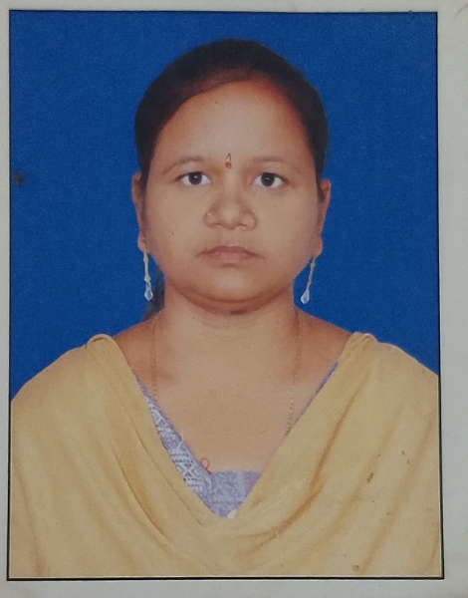
2. Subject : Economics
3. Qualification : M.A.
4. Experiance : 17 Years
5. Books Published : Nil
6. No.of Journals Published : Nil
7. No.Of Scoping Indexed : Nil
8. Citation Index : Nil
9. Teaching paper Name : Economics
10. YouTube links : Nil
11. Blog Links : Nil
12. Awards if any : Nil
13. Mobile Number : 8142514242
14. E-Mail ID : sanjeevaprasadk@gmail.com
15. If any other information : Nil


